Aiden
Aiden Blankenship is a poet, singer-songwriter, and guitarist from the rolling hills of Brown County, Indiana. A lifelong musician who began playing at age 12, Aiden grew up immersed in the music of his family, with both parents as professional musicians who instilled in him a deep love for the art. As a performer, Aiden’s voice is raw and powerful, each performance a window to his soul and a testament to his unwavering commitment to his craft.
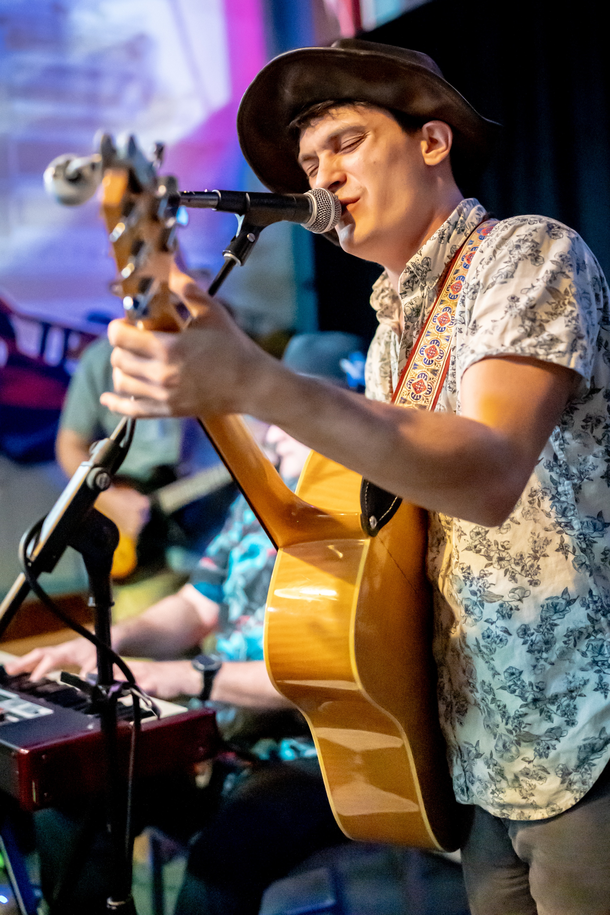
Aiden’s songwriting is steeped in spirituality and wonder, evoking a profound sense of hope and longing that resonates with listeners. His lyrics explore themes of freedom, humanity, and self-expression, reflecting his passion for humanitarianism and his identity as a radical humanist. A true troubadour, Aiden has traveled extensively across the United States, sharing his music with audiences far and wide. Whether on stage or on the road, he embodies the spirit of a wanderer, offering his listeners a glimpse into his journey of seeking, questioning, and connecting through his art.
On Stage -
Aiden has played on stages such as Slippery Noodle Inn, Brown County Inn, Mansion Hill (Cincy), Tootle (Ohio), and many more.
He has played the Southern Indiana Blues Festival, Folk Alliance International, and Folk Alliance Region Midwest
He will be showcasing in the FARM/FARMette room at Folk Alliance 2025.

Music - Here
Contact – aidenblankenshipmusic@gmail.com
Booking – thecreeksidsound@gmail.com
I'm always looking for a new adventure.
aidenblankenshipmusic@gmail.com

